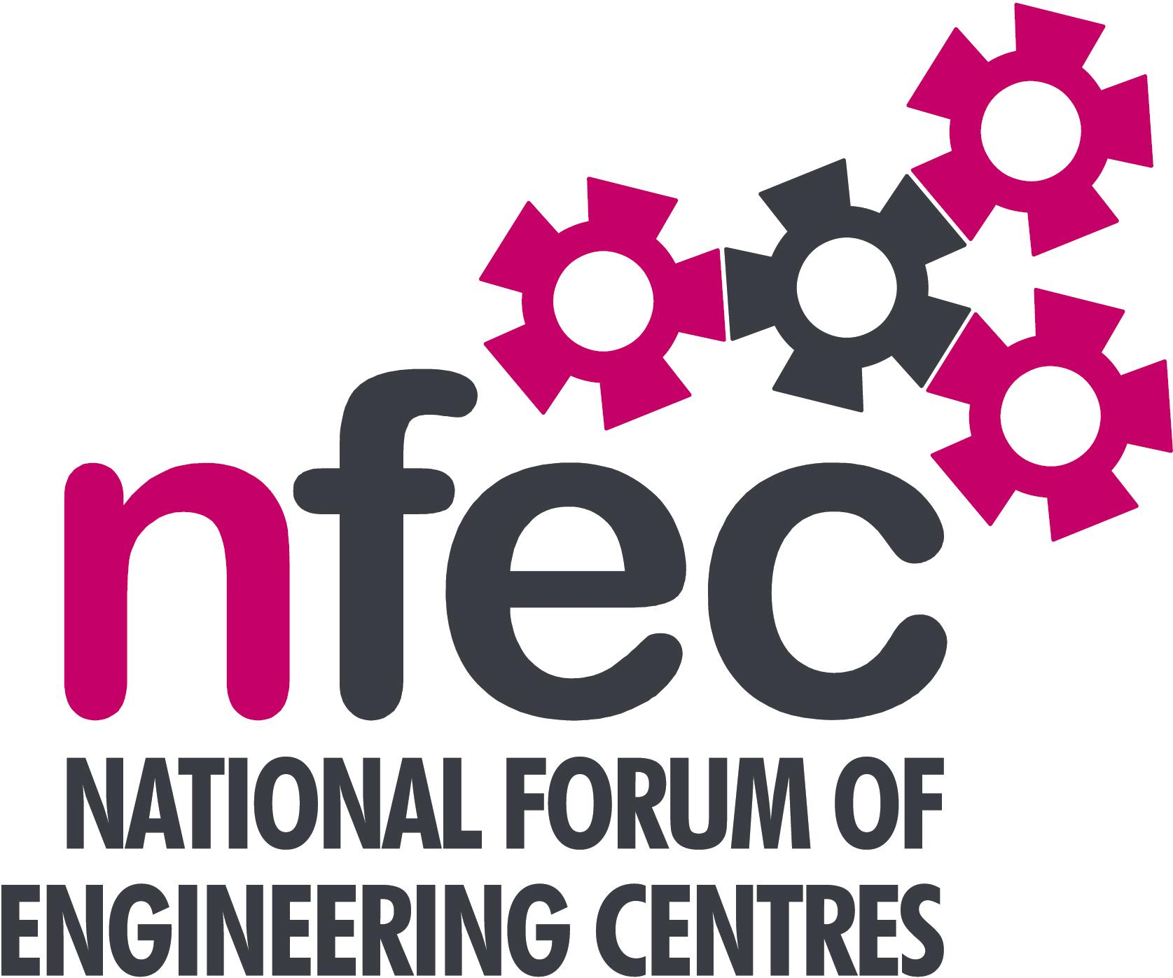
NFEC Spring 2017 North West Regional Seminar

Host: Preston College

Friday 3rd March 2017, 10.15am – 15.00 (Coffee from 10.00am)
Venue: Preston College, St Vincents Road, Fulwood, Preston PR2 8UR
Telephone Number: 01772 225522

Programme

- Welcome and Introduction to the Seminar | Steve McAloone (NFEC North West Regional Coordinator)  Scott Cubitt – Preston College | 10.15
- The Composites Technician Trailblazer Apprenticeship  “An opportunity”  - Demonstration by OneFile of software and an app which can be used on and offline to record training as essentially an eportfolio.  - Update from NWTC on the delivery of a Trailblazer  - Current matters of concern relating to quality, content, structure, management and delivery of programmes of training and education in Engineering (not included on Agenda) - an opportunity for open discussion with a focus to distill key issues and plans for addressing them.  Lunch and Demonstrations by Exhibitors  - Qualifications and Awarding Bodies – Current developments and general issues.  Tour of facilities  - Plenary session – Issues to note and agreed actions for NFEC  - Date, Place and Topics for next Seminar  Close  Entry is free to this seminar for members or to non-members present for a first attendance.There will be a charge for non members after this. A light buffet lunch will be provided and you will be able to see/discuss demonstrations of the latest available equipment and facilities for the delivery of learning in Engineering. | Brian Thornton, National Composites Centre  Anne Stott, OneFile  Shane Parkes, North West Training Council  All Delegates/Steve McAloone  EAL – Dave Ainsworth  Pearson - Amanda Murphy, Georgina Tattersall  C&G – Simon Yorke  AQA – Paul Anderson  OCR – Martin Webber  All delegates/Steve McAloone  To book your place: Email: admin@nfec.org.uk  Phone: 07759 901229 | 10.20  10.45  11.15  11.45  13.00  14.00  14.45

